

HUNTER GATHERER FORUM – KENYA (HUGAFO-K) ANNUAL REPORT 2024 / 2025
Advancing Indigenous Identity, Cultural Revitalization, Land Rights, Climate Resilience, and Community Empowerment

INTRODUCTION
Hunter Gatherer Forum Kenya (HUGAFO-K) is a national platform uniting Kenya’s Hunter Gatherer communities including the Ogiek, Sengwer, Yaaku, El Molo, Aweer (Boni), Wayuu (Waata), and Lmartins of Ntim Nariko Forest. The network advocates for recognition, land security, cultural vitality, sustainable livelihoods, and meaningful participation in national and county governance processes.
The 2024/2025 period was marked by significant advances in community-driven advocacy, strategic development, cultural revival, climate-related education, and policy engagement at national levels. This report documents the major activities undertaken, highlighting progress, achievements, and ongoing challenges.

Table of Contents
HUNTER GATHERER FORUM – KENYA (HUGAFO-K) ANNUAL REPORT 2024 / 2025 1
INTRODUCTION 1
MAIN ACTIVITIES OF THE YEAR 3
HUGAFO-K Empowerment Workshop (18–19 January 2024, Nakuru) 4
Climate Change and Carbon Market Workshop (5–6 June 2024, Nakuru) 5
Yaaku Cultural Event: Bible Translation Launch (8 June 2024, Laikipia) 5
Yaaku Community Land Dialogue (8 October 2024, Doldol) 6
Yaaku Annual General Meeting (30 November 2024, Doldol) 7
Workshop on Adoption of Fundraising Document (5 September 2024, Naivasha) 8
Strategy Review and Development Workshop: 2025–2028 Strategy (6 September 2024, Naivasha) 9
Petition on Recognition of Hunter Gatherer Ethnic Codes (March–April 2025, Nairobi) 10
Petition on Recognition of Hunter Gatherer Ethnic Codes (2nd April 2025 Nairobi) 11
Wayuu Identity Affirmation Forum (15–16 May 2025, Isiolo) 12
Land Tenure Rights Stakeholder Engagement (26 June 2025, Eldama Ravine) 13
Forest Restoration Stakeholder Meeting (1 July 2025, Iten) 14
Sengwer Agroecology Project Launch (20 September 2025, Embobut) 16
Digital & Physical Security Training – International Day of Rural Women (15 October 2025) 17
National Public Participation on the Policy and Bill on Minorities and Marginalized Communities (21–28 October 2025) 18
Fundraising Team Meeting & CLARIFI Concept Note Development (18 November 2025) 18
ACHIEVEMENTS OF THE YEAR 18
CHALLENGES 18
RECOMMENDATIONS 18

MAIN ACTIVITIES OF THE YEAR

TABLE: KEY EVENTS OF THE YEAR

Event | Date | Location
Empowerment Workshop | 18–19 January 2024 | Nakuru
Carbon Market Workshop | 5–6 June 2024 | Nakuru
Yaaku Bible Translation Launch | 8 June 2024 | Laikipia
Yaaku Land Dialogue | 8 October 2024 | Doldol
Shulmai Conservancy AGM | 30 November 2024 | Laikipia
Fundraising Strategy Workshop | 5 September 2024 | Naivasha
Strategy Review Workshop | 6 September 2024 | Naivasha
Petition to NGEC | 20 March 2025 | Nairobi
Petition to KNBS | 2 April 2025 | Nairobi
Wayuu Identity Forum | 15–16 May 2025 | Isiolo
Public Participation on Policy & Bill | 21–28 October 2025 | Across counties
Agroecology Project Launch | 20 September 2025 | Embobut

HUGAFO-K Empowerment Workshop (18–19 January 2024, Nakuru)
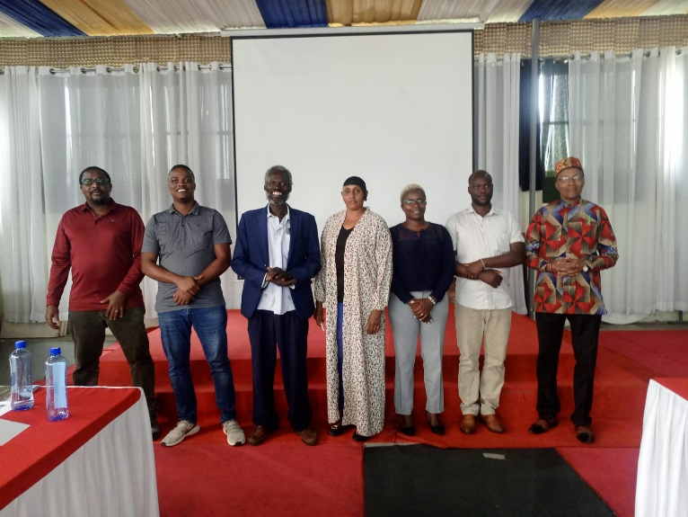
Figure 1:Elected steering committee members
The year began with a comprehensive empowerment workshop hosted in Nakuru. Representatives from all Hunter Gatherer communities participated in discussions that strengthened leadership capacity, enhanced cultural protection efforts, and promoted advocacy skills. The workshop emphasized the need for a revised strategic plan, greater cultural representation in public events, increased fundraising efforts, and improved media visibility. Participants also explored community economic empowerment, carbon credit awareness, Indigenous knowledge documentation, and the importance of joining national taskforces. A major outcome of the workshop was the successful election of the HUGAFO-K Steering Committee.

Climate Change and Carbon Market Workshop (5–6 June 2024, Nakuru)
This highly impactful workshop brought together 32 Indigenous participants from the Ogiek, Sengwer, Endorois, Yaaku, Waata, Wayuu, and El Molo communities. The workshop sensitized participants on climate change, the carbon market, national environmental legislation, and the role of Indigenous peoples in carbon rights and climate resilience. Participants learned about carbon credit opportunities, methods of valuing carbon resources, and negotiation skills needed for community benefit-sharing. The workshop also highlighted the importance of promoting clean energy, integrating environmental education into schools, and producing simplified learning materials for local communities.

Yaaku Cultural Event: Bible Translation Launch (8 June 2024, Laikipia)
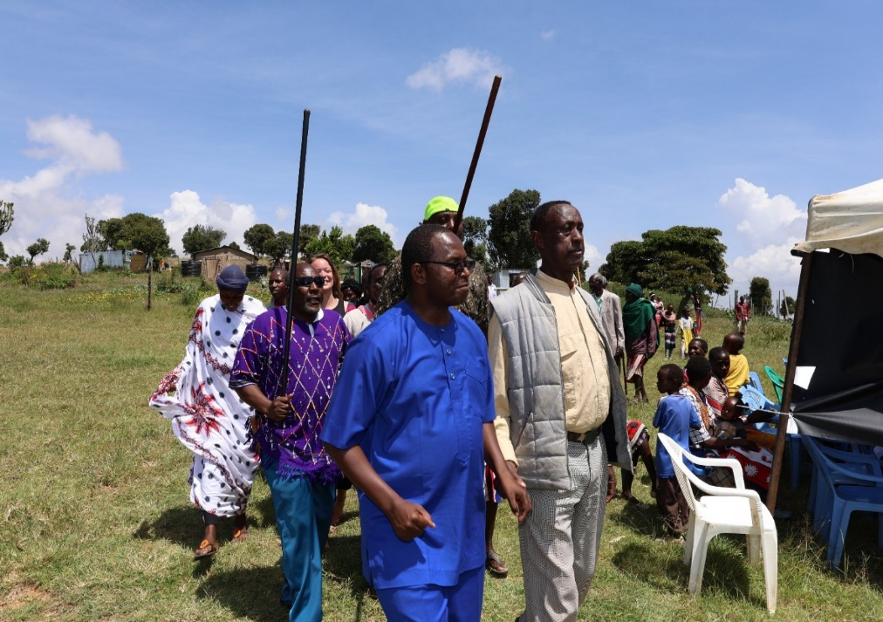
Figure 2:Yaaku cultural celebration
The Yaaku Cultural Centre of Hope hosted a landmark cultural ceremony celebrating the translation of the St. Luke Bible into the Yakunte language. This event marked a major step in endangered language revival and cultural preservation. The ceremony brought together community elders, cultural custodians, youth, and partners committed to revitalizing the Yakunte language. The event reaffirmed the Yaaku community’s commitment to Indigenous knowledge, language transmission, and cultural continuity.

Yaaku Community Land Dialogue (8 October 2024, Doldol)
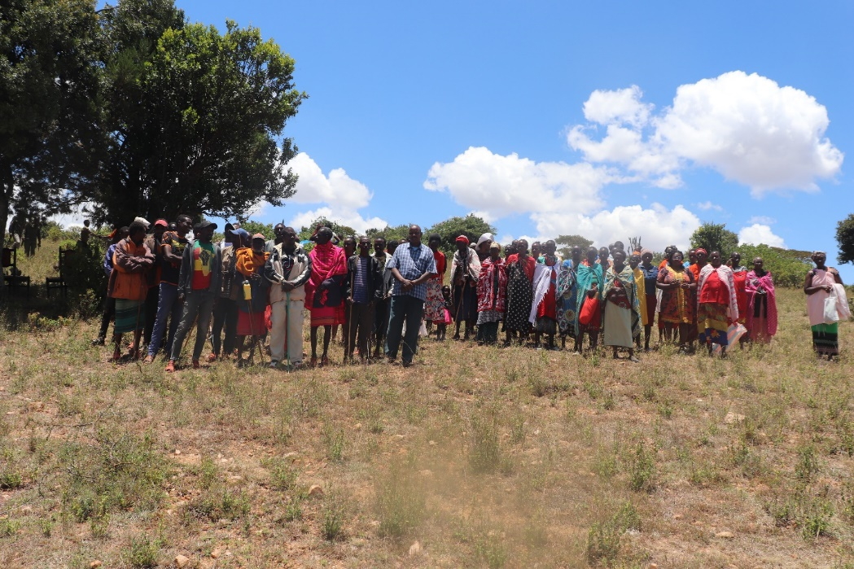
Figure 3:Yaaku community dialogue on mapping
Held in Kurikuri, Laikipia North, this meeting addressed persistent boundary disputes between community and private landowners. The community openly discussed historical grievances dating back to 1974 and the risks associated with unclear boundaries, including potential evictions. Participants resolved to pool resources to hire a professional surveyor to map the contested land and establish definitive boundaries. The forum also emphasized the importance of sensitizing community members on land use and management while encouraging government participation in resolving long-standing land issues.

Yaaku Annual General Meeting (30 November 2024, Doldol)
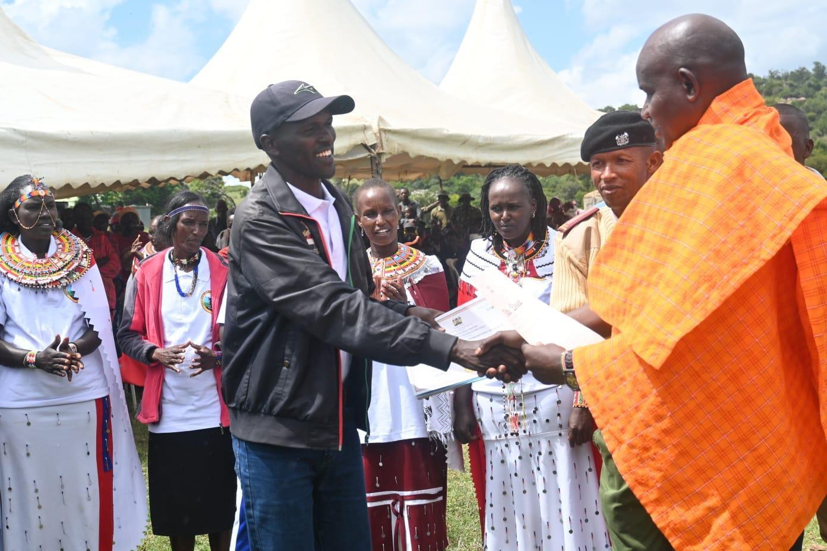
Figure 4:Shulmai conservancy annual meeting
The Yaaku community convened its annual general meeting at Kurikuri Primary School. A key highlight was the official handover of community documents, including the conservancy title deed, to the newly elected Shulmai Conservancy Committee. The event showcased community achievements, strengthened local governance, and reinforced accountability structures. Communities agreed on the need for continuous peacebuilding engagement with neighbouring conservancies and stronger project monitoring practices.

Workshop on Adoption of Fundraising Document (5 September 2024, Naivasha)
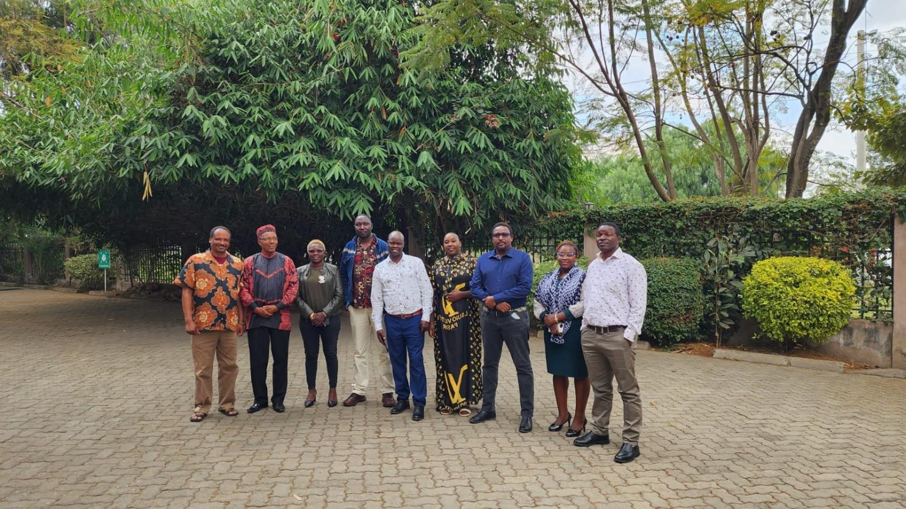
Figure 5:Steering committee group photograph
Held at Chambai Safari Hotel, this workshop focused on formalizing HUGAFO-K’s fundraising strategy. Participants reviewed financial frameworks, discussed the operationalization of fundraising tools, and emphasized the importance of establishing essential office resources such as official letterheads, laptops, and internet access. The workshop also promoted website improvements and encouraged communities to submit their concepts for community coding initiatives. Partnerships with regional organizations, including the East Africa Women-Led Assembly, were also explored to strengthen collaboration and resource sharing.

Strategy Review and Development Workshop: 2025–2028 Strategy (6 September 2024, Naivasha)
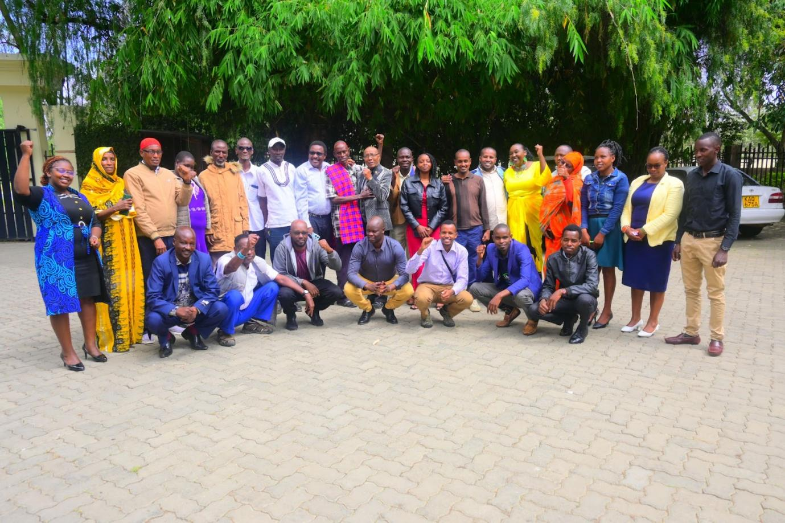
Figure 6:Group photograph
This workshop reviewed the expiring 2021–2024 strategic plan and initiated the development of a new strategy for 2025–2028. Community representatives identified priority areas including land tenure, cultural preservation, advocacy frameworks, youth involvement, and institutional strengthening. The workshop also initiated the onboarding of new communities into the HUGAFO-K network and promoted knowledge exchange on biocultural protocols. The session ended with an agreement to convene a physical meeting to finalize the draft strategy.

Petition on Recognition of Hunter Gatherer Ethnic Codes (March–April 2025, Nairobi)
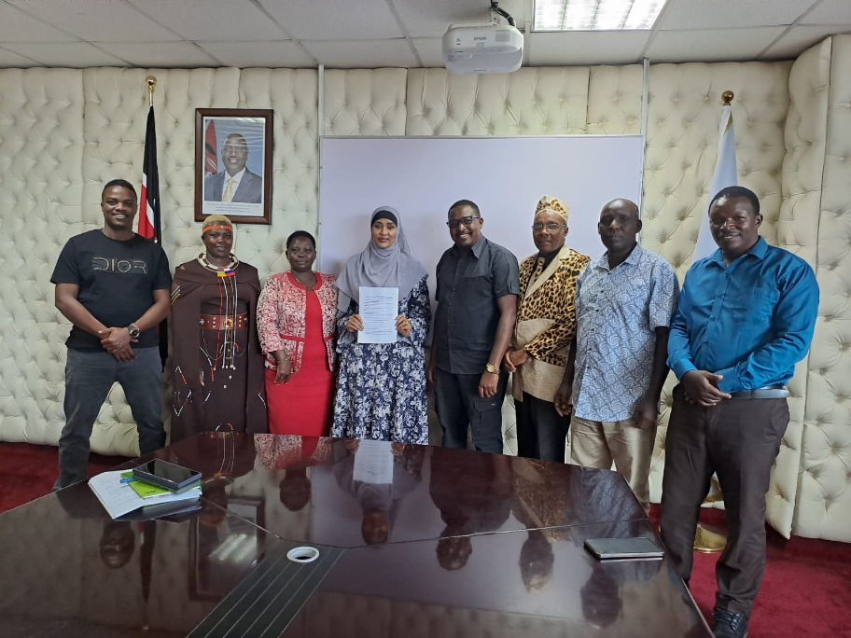
Figure 7:Petition to NGEC
In a historic advocacy effort, members of the Steering Committee presented a petition to the National Gender and Equality Commission on 20 March 2025, seeking official recognition of Hunter Gatherer communities through ethnic codes. Due to insufficient historical documentation, the committee sought further consultation with the Kenya National Bureau of Statistics (KNBS).

Petition on Recognition of Hunter Gatherer Ethnic Codes (2nd April 2025 Nairobi)

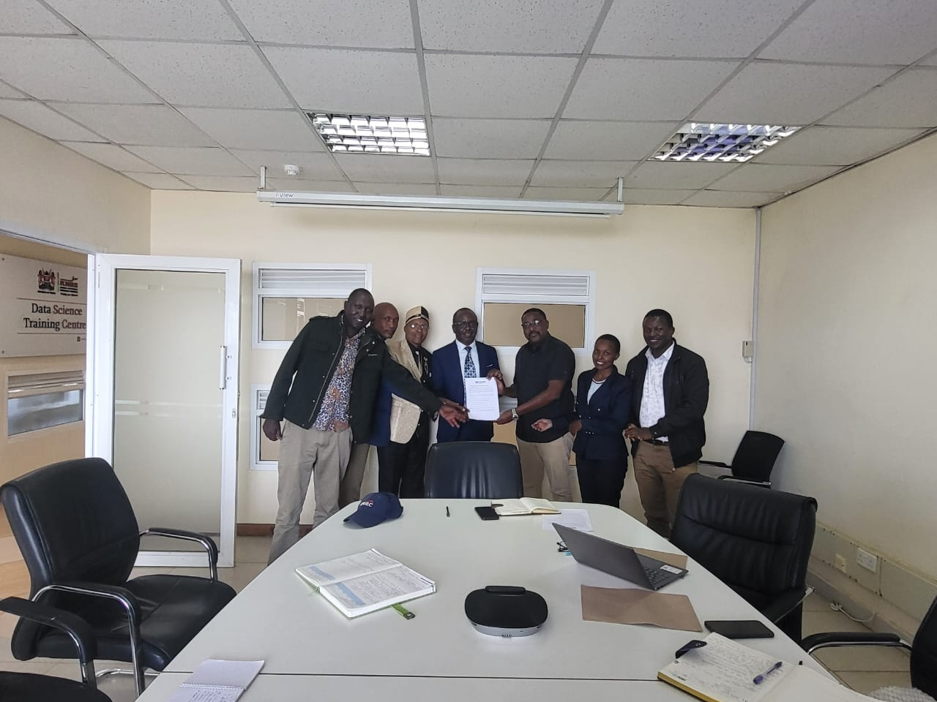
Figure 8;Petition to KNBS
On 2 April 2025, the representatives visited KNBS to request biometric data, a review of existing derogatory names, a pilot survey, and the establishment of a joint task force for future census inclusion. KNBS expressed willingness to collaborate and provide necessary data to support advocacy efforts. This step marked a significant milestone toward Indigenous visibility in national statistics.

Wayuu Identity Affirmation Forum (15–16 May 2025, Isiolo)
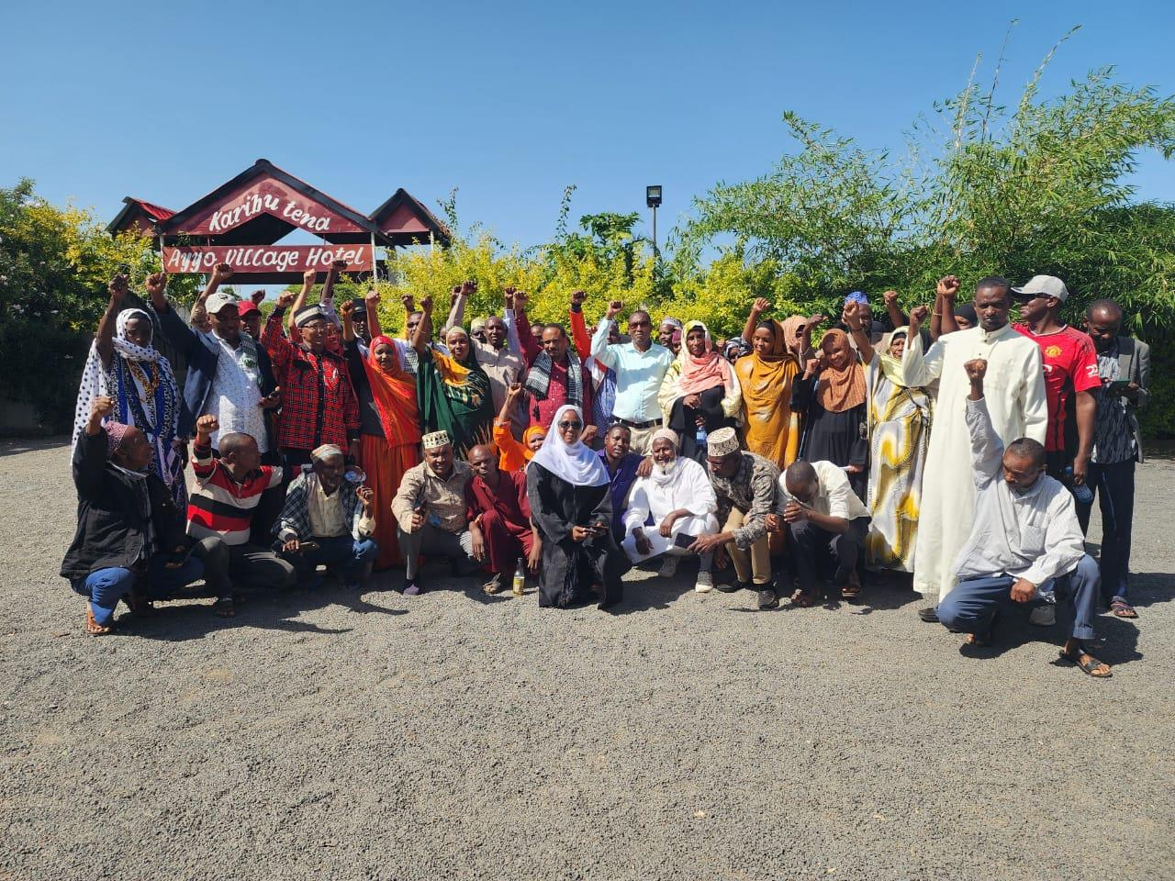
Figure 9:Wayuu/watta group photograph

This pivotal meeting focused on reclaiming the dignified identity of the Wayuu community, replacing the derogatory label “Waata.” The forum involved intergenerational dialogue on the impact of cultural misrepresentation and aimed to unify dispersed Wayuu populations across regions. Participants agreed on establishing structured community institutions such as the Wayuu Council of Elders, Youth Council, and Women’s Council. The meeting also prioritized documentation of Wayuu history, cultural knowledge, and community land registration efforts.

Land Tenure Rights Stakeholder Engagement (26 June 2025, Eldama Ravine)
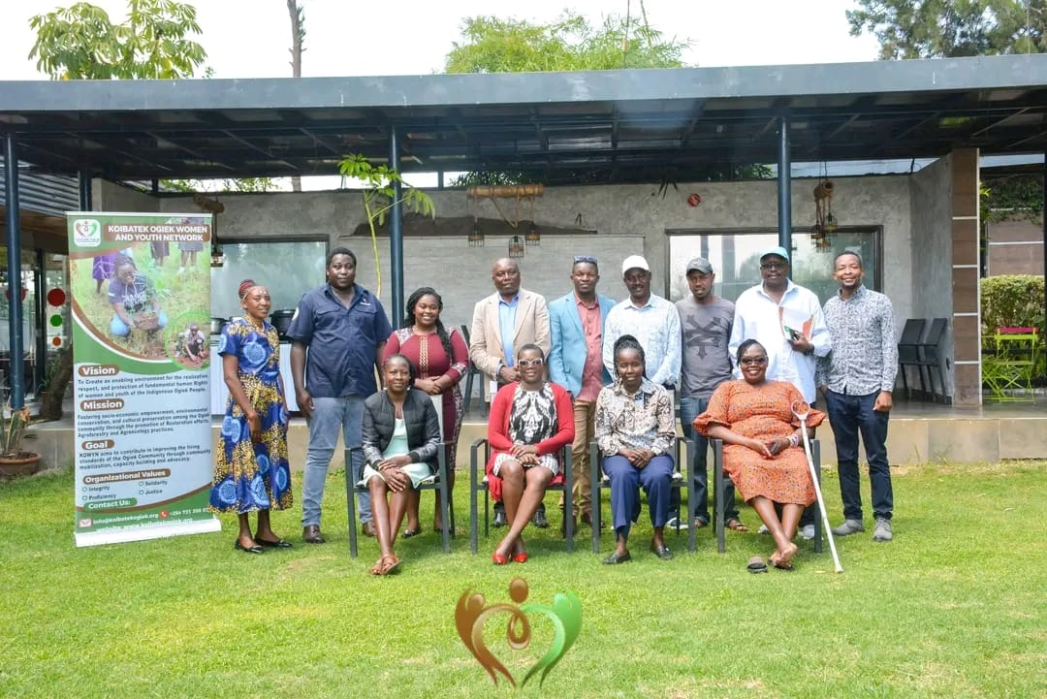
Figure 10:Stakeholders meeting in Koibatek
The Koibatek Ogiek Women and Youth Network (KOWYN) invited HUGAFO-K to a multi-stakeholder engagement addressing land tenure rights. The meeting covered the ongoing Ogiek land struggle, implications of the African Court decision, and the role of the Community Land Act in securing land titles. Participants emphasized women and youth involvement in land governance and recognized the importance of cross-agency collaboration for achieving lasting land justice.

Forest Restoration Stakeholder Meeting (1 July 2025, Iten)
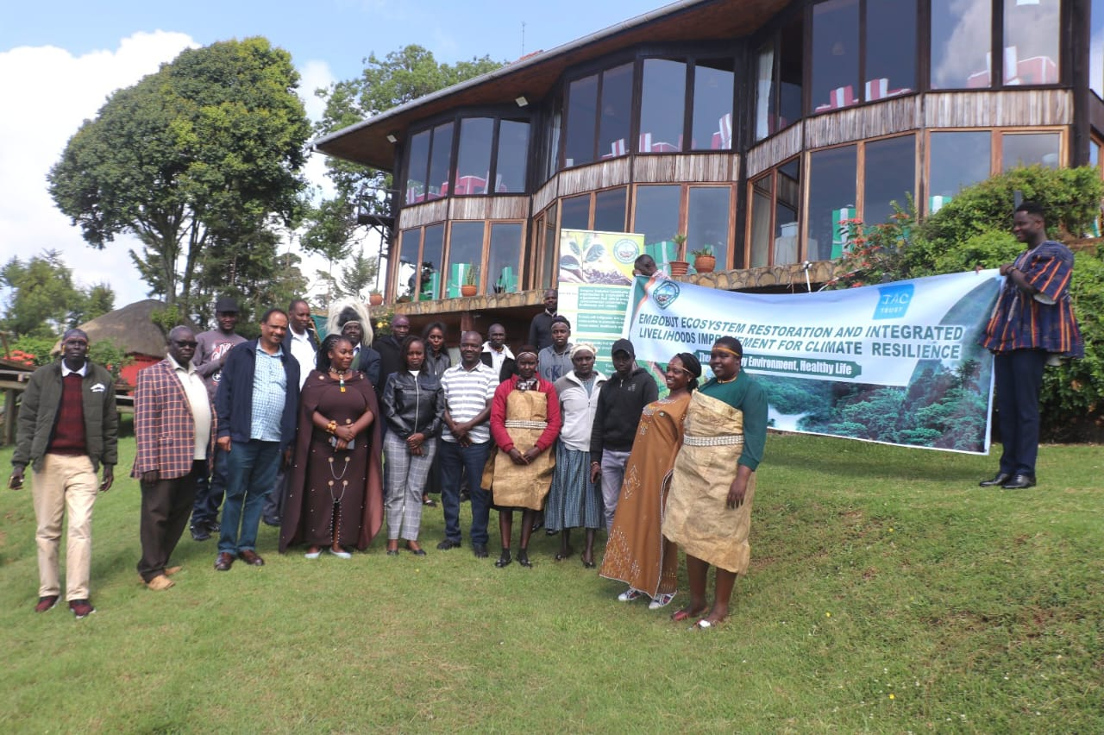
Figure 11:Forest Restoration Stakeholder meeting
Hosted by the Sengwer Embobut Community-Based Organization (SECBO), this meeting focused on a long-term restoration project aimed at planting 2.5 million indigenous and fruit trees, establishing tree nurseries, and promoting agroecology. The dialogue highlighted the strong correlation between forest degradation and unresolved land rights, pointing to the necessity of secure tenure for sustainable restoration. The meeting also emphasized the role of Indigenous ecological knowledge, community-led monitoring, and youth engagement in environmental conservation.

Yaaku petition to The National Assembly
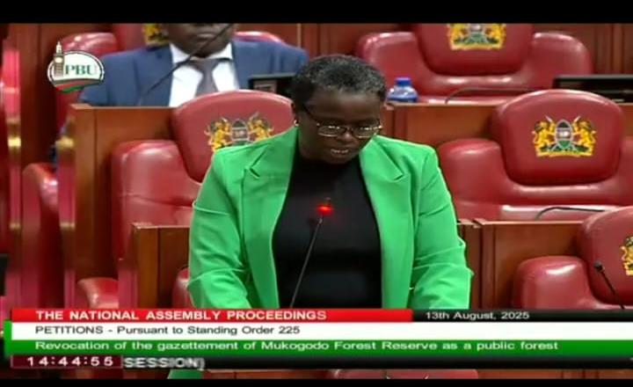
Figure 12:Motion on revocation of the Gazettement of Mukogodo forest
The Yaaku community, one of Kenya’s few remaining hunter-gatherer indigenous peoples, submitted a formal petition on 13th August to the National Assembly through the Public Participation Committee, seeking the revocation of Gazette Notice No. 174 of 1964, which declared Mukogodo Forest Reserve as public land.
Mukogodo Forest—located in Laikipia North Sub-County—has been home to the Yaaku community since the 14th century. However, since 1964, when the colonial-era gazette notice converted the forest into a government reserve, the Yaaku have faced decades of land dispossession, cultural marginalization, and restricted access to their ancestral lands.
Key Recommendations of the Petition:
1. Revoke Gazette Notice No. 174 of 1964, which classified Mukogodo Forest as public land and subsequently gazette as a community forest
2. Reclassify and gazette 30,189 hectares of the forest as Community Land, 20,000 hectares to be managed under community forest laws by the Yaaku Indigenous Community, in accordance with Article 63 of the Constitution and the Community Land Act, 2016.
3. Allocate the remaining 10,000 hectares of the forest for the resettlement and livelihood support of the Yaaku community, many of whom remain landless and marginalized.

Sengwer Agroecology Project Launch (20 September 2025, Embobut)
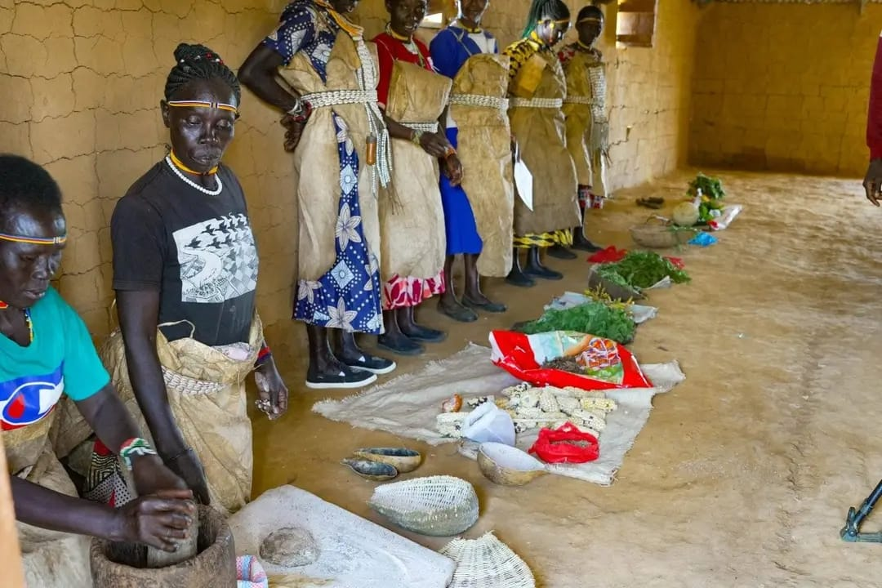
Figure 13:Sengwer agroecology project
This event launched the “Roots of Sovereignty” Agroecology Project, which aims to revive Indigenous foods, empower women and youth, and enhance climate-resilient agriculture. The project combines community-driven knowledge with organic farming practices and seed-saving initiatives. It also strengthens food sovereignty and contributes to climate adaptation strategies aligned with global sustainability goals.

Digital & Physical Security Training – International Day of Rural Women (15 October 2025)

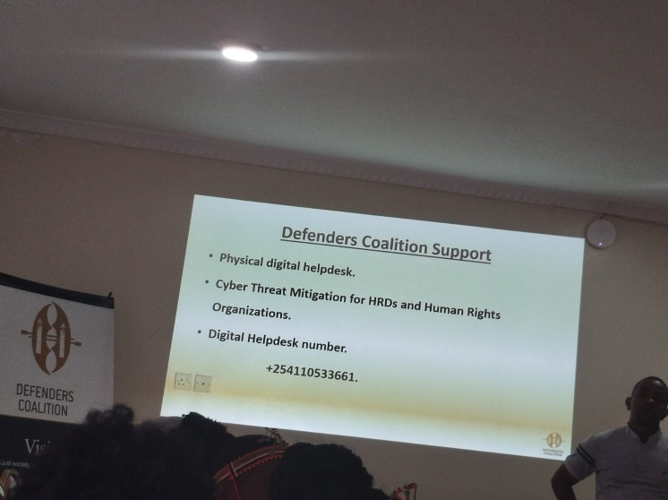
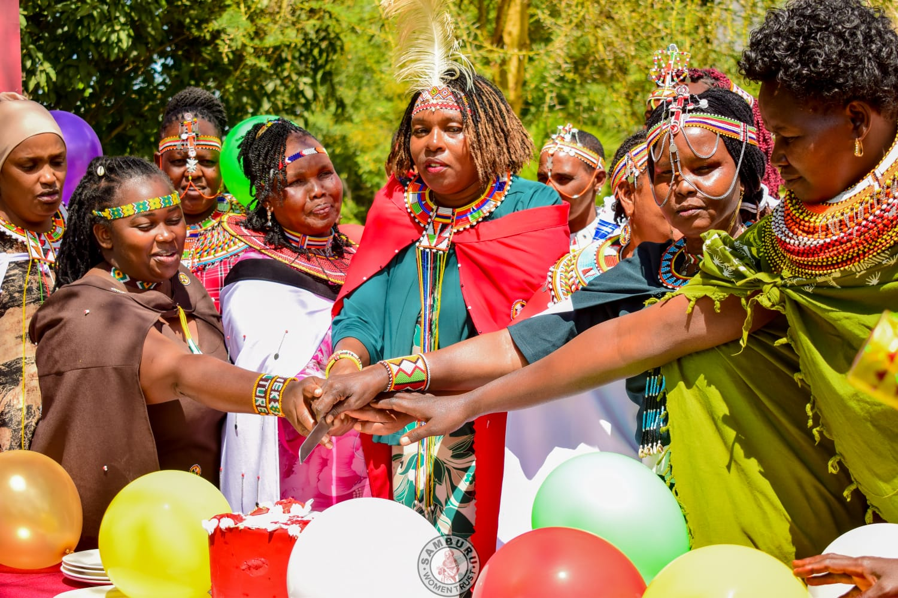
Figure 14:Digital security training
Figure 15:International rural women’s day celebration

HUGAFO-K participated in a comprehensive digital security training during International Rural Women’s Day. The program trained Indigenous women on protecting their digital identity, secure communication, documenting community issues safely, and creating digital content that amplifies their stories. This initiative significantly strengthened the digital advocacy capacity of Indigenous women across different regions.

National Public Participation on the Policy and Bill on Minorities and Marginalized Communities (21–28 October 2025)
HUGAFO-K played a critical role in supporting all Hunter Gatherer communities to engage in national public participation for the proposed Policy and Bill. Through mobilization, coordination, and continuous guidance, each community successfully drafted and submitted memoranda to their respective County Commissioners. Communities consulted included the Ogiek (various regions), Sengwer, Aweer, El Molo, Yaaku, Wayuu, and others. This process strengthened community voices and ensured their priorities were included in national policymaking.

Fundraising Team Meeting & CLARIFI Concept Note Development (18 November 2025)
The fundraising team convened a virtual meeting to follow up on resource mobilization strategies and initiate the development of a CLARIFI concept note. This step is intended to strengthen HUGAFO-K’s ability to access long-term funding to sustain programs, advocacy efforts, and community engagements.

ACHIEVEMENTS OF THE YEAR
- Official unification of Wayuu identity across regions
- Commitment from KNBS to support biometric data access
- Growth of HUGAFO-K membership and representational strength
- Advancements in cultural revitalization, including Bible translation and dictionary efforts
- Women, youth empowerment and agroecology initiatives in Embobut
- Successful coordination of national public participation across all communities
- Strengthened Policy Engagement-All communities under HUGAFO-K successfully submitted memoranda on the National Policy and Bill on Ethnic Minorities and Marginalized Communities to their respective County Commissioners.
- Membership in the Indigenous Women’s Coalition (IWC)

CHALLENGES
- Limited funding to support widespread community activities, logistical
- Delays in securing official ethnic coding.
- Cultural erosion, weak intergenerational transfer of knowledge.
- Unresolved land disputes also presented significant barriers.

RECOMMENDATIONS
- Strengthen strategic planning and ensure alignment with emerging community needs.
- Expand fundraising initiatives and secure sustainable financial resources.
- Improve documentation, media visibility, and website functionality.
- Follow up with NGEC and KNBS for recognition of ethnic codes.
- Promote cultural revitalization programs and the protection of Indigenous languages.
- Increase climate education and develop accessible carbon literacy materials.
- Enhance youth leadership and participation in community governance.
- Support community land registration and initiate boundary survey programs.
- Establish and strengthen Indigenous governance institutions such as councils of elders and women’s groups.
- Deepen partnerships with civil society, government, and international organizations.

